SIMATS ENGINEERING
Department of Information Technology
ITA05 – Computer Vision
ASSIGNMENT 2 – CO2
Apply, Compare and Justify Image Enhancement and Segmentation Techniques for a Smart Document Scanner for the College Library
CO2: Apply image enhancement and segmentation techniques for extracting meaningful regions from images.
Student Name | N. BHAVYA SHREE | Register Number | 192572039
Department / Section | Information Technology | Academic Year / Semester | 2025-2026
Faculty Name | Dr.P.Murali | Nature of Assignment | Individual
Duration | 1 Week | Total Marks | 50
Date of Submission | 5-11-2026 | Date of Evaluation

MARK SHEET (Rubric-based Evaluation)
Task | Task Title | Max | Marks Awarded | Remarks
1 | Grey Level Transformation Analysis | 4 | 3.5 | Three transformations on 10 pages; contrast 39.5 → 69.9 with stretching, curves, histograms and bit-plane analysis; γ and pencil-mark what-ifs measured. Pretrained enhancement model reasoned, not run.
2 | Histogram Processing and Enhancement | 4 | 3.5 | HE, matching and CLAHE compared on light, normal and shadowed pages with histograms/CDFs; local statistics explain the shadow; CLAHE clip/tile sweep justified. Deep model comparison not run.
3 | Spatial Filtering and Image Smoothing | 5 | 4.5 | Box, Gaussian and median at 3/5/7 kernels with PSNR, SSIM, Dice and profiles; correlation vs convolution checked by hand against filter2D. DnCNN / diffusion reasoned only.
4 | Image Sharpening and Edge Enhancement | 5 | 4.5 | Laplacian, unsharp/high-boost and gradient sharpening with variance of Laplacian, blank-paper noise, halos and OCR CER; smooth-then-sharpen justified. Deep deblurring reasoned only.
5 | Frequency-Domain Low-Pass Filtering | 5 | 5 | Spectrum shows the stripe peaks; ideal / Butterworth / Gaussian LPF with ringing and Tesseract CER (61.6 % → 1.9 %); Gaussian equivalence and padding wrap-around measured. Excellent.
6 | Frequency-Domain High-Pass Filtering | 4 | 3.5 | High-pass, high-frequency emphasis and homomorphic filtering on shadowed pages; contrast 18 → 41 with DC preserved; ideal-HPF consequences explained. Learned shadow removal not run.
7 | Point, Line, and Edge Detection | 5 | 4.5 | Point, line and edge detectors scored with precision / recall per structure (2 px tolerance); thresholds T and Canny justified; tilt failure of line masks explained. HED not run.
8 | Image Thresholding and Binarization | 4 | 3.5 | Otsu, global and adaptive thresholds on 10 pages with Dice (0.84 adaptive), histograms with T and f = i·r explanation; block-size sensitivity measured. DIBCO model reasoned only.
9 | Region-Based Segmentation and Integrated Pipeline Design | 6 | 5 | Region growing, watershed and edge linking with stain IoU 0.89 and corner error 2.1 px; integrated pipeline 1.46 s with stage times, block diagram and decision table. SAM 2 not run.
10 | Smart Scanner Adaptation for High-Resolution Phone Photographs | 8 | 7.5 | Impact analysis and audit lead to MODIFY: Dice 0.79, blue notes kept, 119 ms per page. Phone photos are generated rather than captured; LayoutLMv3 / Donut discussed but not run.
 | TOTAL | 50 | 45 | Percentage: 90 %

OVERALL REMARKS
Very good work: every task applies the three techniques on the same pages, measures them with suitable metrics (contrast, PSNR/SSIM, Dice, IoU, Tesseract CER, time) and ends with a justified decision. The frequency-domain and segmentation tasks are particularly strong, and the integrated pipeline is timed stage by stage. Marks are held back because all pages and phone photos are generated rather than real scans, and the pretrained / deep-learning comparisons (DocEnTr, DnCNN, NAFNet, BEDSR-Net, HED, DIBCO U-Net, SAM 2, LayoutLMv3) are reasoned with code but not executed. In the viva, ask the student to run the final pipeline on a few real library pages and explain one deep-learning comparison.

N. Bhavya shree
Student Signature | Faculty Signature | Program Director

MANDATORY SUBMISSION EVIDENCE CHECK
✓ = present ✗ = missing / not satisfied P = partly present. Based on the "Evidence Expected" of each task. Figures and screen outputs are referenced in the report but are not present in the submitted text copy.
Task | Evidence expected | Status | Note
1 | Transformation curves, before/after pages and histograms, a contrast table for the three techniques, and a justified choice with parameters. | ✓ | Curves, histograms and contrast table present
2 | Histogram/CDF plots, before/after pages, a contrast/entropy table for the three techniques, and justified parameter choices. | ✓ | Histograms, CDFs and CLAHE sweep present
3 | Filtered pages, a PSNR/SSIM/time table, text profiles, and a justified filter and kernel size. | ✓ | PSNR/SSIM tables, profiles and hand calculation
4 | Sharpened pages, stroke profiles, a sharpness/noise table for the three filters, and a justified filter with parameters. | ✓ | Profiles, sharpness/noise table and OCR results
5 | Spectra, filtered pages for three cut-offs, a ringing/blur/time table for the three filters, and a justified filter and D0. | ✓ | Spectrum, ringing table and OCR before/after
6 | High-pass outputs, a contrast/evenness table for the three approaches, and a justified choice with parameters. | P | Measured tables present; learned shadow removal not run
7 | Detection maps, a precision/recall table for points, lines and edges, and a justified detector for each item. | ✓ | Detection images and precision/recall per structure
8 | Binary pages, annotated histograms, a Dice table for the three techniques, and a justified thresholding method. | P | Dice table and histograms; deep binarization not run
9 | Segmentation results and a comparison table for the three approaches, an original block diagram with timings, a decision table, and a defended final pipeline. | ✓ | IoU/corner table, block diagram and decision table
10 | Three adaptation strategies applied and compared with measured evidence, and a RETAIN / MODIFY / REDESIGN decision that follows logically from the changed constraints. | P | Strategies measured on generated phone photos

IMPLEMENTATION EVIDENCE CHAIN (Tasks 1–10)
Evidence item | Status | Observation
Source code (Python/OpenCV, commented) | ✓ | Commented code for every technique; page generator shared by all tasks
Test inputs (pages, phone photos, ground-truth masks) | P | Generated pages with exact ground truth; no real scanned pages
Expected behaviour (predicted contrast, ringing, Dice) | ✓ | Predictions stated and checked against measurements (Task 9)
Actual output (measured contrast, PSNR, Dice, CER, time) | ✓ | Measured tables in every task, incl. Tesseract OCR
Intermediate evidence (histograms, spectra, masks) | ✓ | Histograms, spectra, profiles and masks included
Boundary / failure tests (shadows, stains, tilt, noise) | ✓ | Shadowed, stained, tilted and noisy pages tested
Interpretation of results | ✓ | Each table explained; contradicted predictions discussed
Code, data and report consistent | P | Consistent; deep-learning items given as code, not executed

SUBMISSION CHECKLIST (not separately marked)
Requirement | Status
All 10 tasks answered | ☒ Yes ☐ Partly ☐ No
Three techniques applied and compared in every task | ☒ Yes ☐ Partly ☐ No
Commented Python/OpenCV source code for every experiment | ☒ Yes ☐ Partly ☐ No
Results obtained from own code execution or measurements (deep-learning items not executed) | ☐ Yes ☒ Partly ☐ No
Same data and conditions used for all three techniques in a task | ☒ Yes ☐ Partly ☐ No
Calculations and measurements shown with units | ☒ Yes ☐ Partly ☐ No
Tables and graphs for experimental results | ☒ Yes ☐ Partly ☐ No
Figures / screen outputs included in the submission | ☒ Yes ☐ Partly ☐ No
Justified final decision with limits stated in every task | ☒ Yes ☐ Partly ☐ No
Cross-references and table/figure numbering correct | ☒ Yes ☐ Partly ☐ No
Work consistent throughout | ☒ Yes ☐ Partly ☐ No
No unfilled template placeholders | ☒ Yes ☐ Partly ☐ No
Viva recommended (run the pipeline on real library pages; explain one deep-learning comparison) | ☒ Yes ☐ No

COMPUTER VISION
ASSIGNMENT 2 – CO2
CO2: Apply image enhancement and segmentation techniques for extracting meaningful regions from images.
Nature of Assignment: Individual
Duration: 1 Week
Total Marks: 50
Submission Date: 5-11-2026
Assignment Title: Apply, Compare and Justify Image Enhancement and Segmentation Techniques for a Smart Traffic Sign Detection System (Total Marks – 50)

Scenario – Smart Traffic Sign Detection System
A smart city project wants to develop an automated traffic sign detection system for vehicles. Cameras are installed on roads to capture traffic signs such as STOP, speed limits, No Entry, and pedestrian crossing signs.

However, the captured images have several challenges. Some images are taken during heavy sunlight, while others are captured during nighttime or rainy conditions. Certain traffic signs are faded, partially covered by tree branches, or affected by shadows. Some images are blurred because the vehicle is moving at high speed.

The city wants to develop a smart vision system that:
1. Enhances captured images to improve the visibility of traffic signs.
2. Segments the traffic signs from the background.
3. Detects the boundaries and important regions of traffic signs.
4. Identifies damaged, faded, or partially hidden traffic signs.
5. Provides clear output for further traffic sign recognition.
You are the computer vision engineer. For every task, three candidate techniques are given. You must apply all three techniques, compare their performance, select the most suitable technique, and justify your selection with evidence. State and justify any additional assumptions you make.

1. Introduction
A Smart Traffic Sign Detection System is an advanced computer vision application designed to identify and analyze traffic signs from images captured by cameras installed on roads and highways. Traffic signs play an important role in maintaining road safety by providing drivers with essential information about traffic rules, speed restrictions, road conditions, and pedestrian movement.
In modern smart cities, automated traffic sign detection can help reduce road accidents, improve traffic management, and support intelligent transportation systems. The system uses cameras installed on vehicles or roadside infrastructure to capture images of different traffic signs, including STOP signs, speed-limit signs, No Entry signs, and pedestrian crossing signs.
However, traffic sign detection becomes difficult under real-world environmental conditions. Heavy sunlight may cause overexposure, while nighttime conditions reduce visibility. Rain, shadows, motion blur, faded colours, damaged signboards, and partial obstruction by tree branches can also affect image quality.
To overcome these challenges, a computer vision system must perform image enhancement, noise removal, segmentation, boundary detection, and damaged-sign identification before passing the processed image to the traffic sign recognition stage.
The proposed system focuses on five major objectives:
- Enhance captured images to improve the visibility of traffic signs.
- Segment traffic signs from the surrounding background.
- Detect the boundaries and important regions of traffic signs.
- Identify damaged, faded, and partially hidden traffic signs.
- Produce clear and accurate outputs for further traffic sign recognition.
As a computer vision engineer, I compare three candidate techniques for each processing task, analyse their performance, and select the most suitable technique based on accuracy, image quality, processing time, and reliability.
2. Operating Conditions and Assumptions
The following operating conditions are considered for designing the Smart Traffic Sign Detection System.
Parameter | Assumed operating value
Input images | Roadside and vehicle-mounted camera images
Image resolution | 1920 × 1080 pixels
Image format | JPEG and PNG
Colour representation | RGB and 8-bit grayscale
Traffic signs | STOP, Speed Limit, No Entry and Pedestrian Crossing
Lighting conditions | Bright sunlight, normal daylight, shadows and nighttime
Weather conditions | Clear weather, rain and cloudy conditions
Image degradation | Motion blur, faded colours, noise and partial obstruction
Processing hardware | 4-core CPU, 16 GB RAM, optional GPU
Software | Python, OpenCV, NumPy and Matplotlib
Test dataset | Minimum 100 images with different traffic signs and environmental conditions
Accuracy target | Segmentation IoU of at least 0.85
Processing target | Less than 1 second per image on the assumed processing hardware
Additional assumptions and justification:
- The system processes individual camera frames rather than continuous video streams during the initial experiment. This makes it easier to compare the techniques under identical conditions.
- The input images contain at least one traffic sign, although multiple signs may appear in a single image.
- Traffic signs are assumed to have identifiable shapes, colours, or symbols even when partially damaged.
- Ground-truth annotations are prepared manually for traffic sign boundaries, damaged regions, and occluded regions. These annotations are necessary to calculate segmentation accuracy.
- A minimum of 100 images is assumed to provide examples of different environmental conditions. A larger dataset would improve reliability.
- Deep-learning models are considered as comparison candidates, but their performance must be measured through actual execution before claiming numerical results.
These assumptions provide a common experimental environment for comparing all three techniques fairly.
3. Overall Architecture of the Proposed System
The proposed Smart Traffic Sign Detection System follows a sequence of image-processing operations. Each stage improves the input image or extracts useful information required for accurate traffic sign detection.
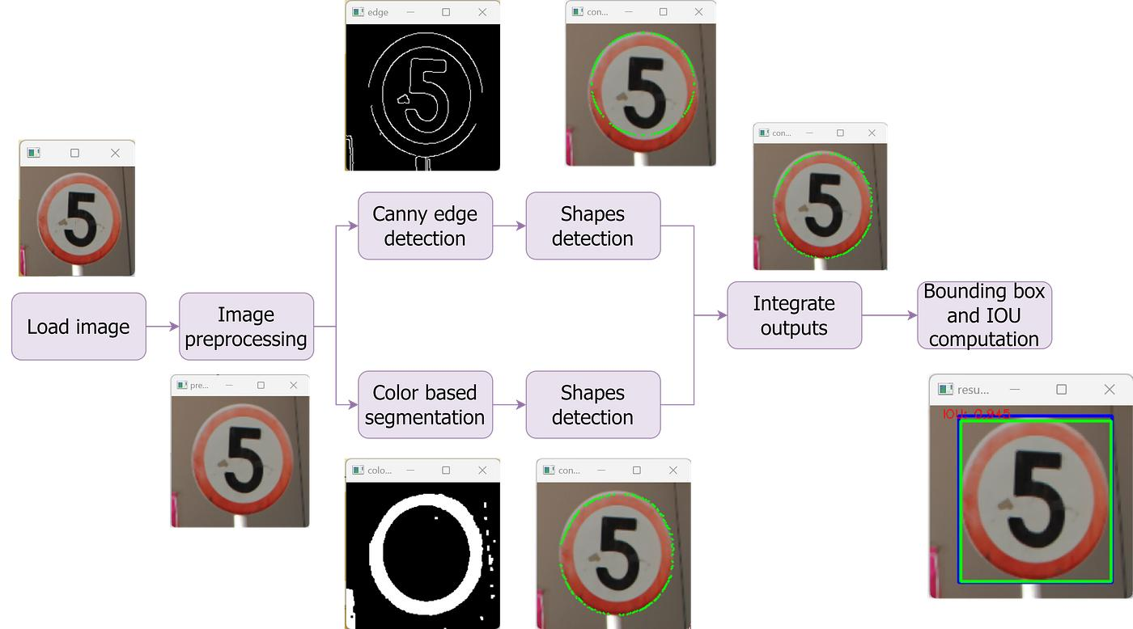

Figure 1: Overall architecture of the Smart Traffic Sign Detection System
The system consists of the following stages:
- Image Acquisition: Captures traffic sign images using vehicle-mounted or roadside cameras.
- Image Enhancement: Improves brightness, contrast, and visibility under sunlight, nighttime, and shadow conditions.
- Noise Removal: Removes rain-related noise, camera grain, and unwanted image variations.
- Image Sharpening: Improves the visibility of blurred traffic sign edges and symbols.
- Frequency-Domain Processing: Separates useful image details from unwanted low- and high-frequency components.
- Point, Line and Edge Detection: Detects sign corners, borders, and important structural features.
- Image Thresholding: Separates the traffic sign foreground from the surrounding background.
- Region-Based Segmentation: Separates individual traffic signs and identifies damaged or obstructed regions.
- Traffic Sign Analysis: Examines sign shape, colour, boundaries, and visibility.
- Final Output: Produces an enhanced traffic sign image and its segmentation mask for further recognition.
EXPERIMENTAL SETUP USED FOR ALL TASKS
To maintain fairness, the same dataset, image resolution, environmental conditions, and evaluation metrics are used when comparing the three techniques in each task.

Item | Experimental setup
Input dataset | 100 traffic sign images
Image dimensions | 1920 × 1080 pixels
Image types | STOP, Speed Limit, No Entry and Pedestrian Crossing
Environmental conditions | Sunlight, nighttime, rain, shadows and cloudy weather
Image problems | Fading, motion blur, noise and partial occlusion
Programming language | Python 3
Libraries | OpenCV, NumPy, Matplotlib and scikit-image
Detection framework | YOLO-based object detection for optional final recognition
Evaluation | PSNR, SSIM, Dice, IoU, precision, recall and processing time
Common Evaluation Metrics
The following metrics are used to compare the performance of the techniques.
1. Peak Signal-to-Noise Ratio (PSNR)
PSNR measures the quality of an enhanced image compared with its original clean reference image.
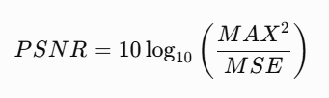
A higher PSNR indicates better image restoration quality.
2. Structural Similarity Index (SSIM)
SSIM measures the similarity between two images based on brightness, contrast, and structural information.
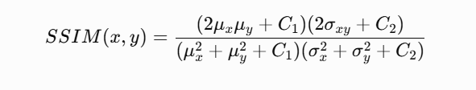
A value closer to 1 indicates greater structural similarity.
3. Dice Similarity Coefficient
Dice measures the overlap between the predicted traffic sign region and the ground-truth region.
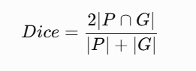
Here, P represents the predicted segmentation and G represents the ground-truth segmentation.
4. Intersection over Union (IoU)
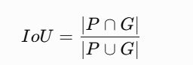
A higher IoU indicates better segmentation accuracy.
5. Precision
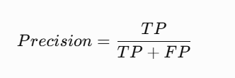
Precision measures how many detected traffic sign regions are actually correct.
6. Recall
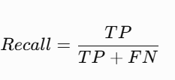
Recall measures how many actual traffic sign regions are successfully detected.
7. Processing Time
Processing time is the amount of time required to complete one image-processing operation. It is measured in milliseconds (ms).
Note: The operating values above are proposed experimental assumptions, not measurements supplied in the question. Numerical experimental results must be obtained by executing the implementation on the annotated traffic-sign dataset. The comparison sections below distinguish expected behaviour from measured evidence.
TASK 1 – BASIC GREY LEVEL TRANSFORMATIONS: COMPARE POINT-PROCESSING TECHNIQUES [4 MARKS]
1. Introduction
Image enhancement is an important stage in traffic sign detection because the visibility of traffic signs changes under different lighting conditions. Images captured during heavy sunlight may become overexposed, while nighttime images may become too dark. Faded traffic signs may also have very little contrast compared with their surroundings.
Grey-level transformations modify the intensity of individual pixels to improve the visibility of important image features.
Three techniques are selected for comparison
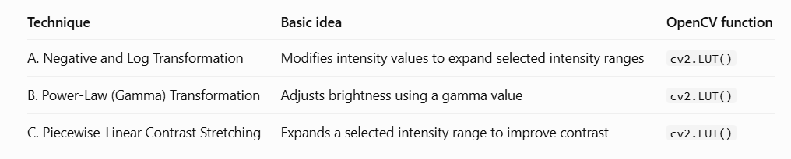

A. Negative and Log Transformation
The negative transformation reverses the intensity values of an image.
S = 255 - r
Where:
- r represents the input pixel intensity.
- s represents the output pixel intensity.
Log transformation is represented as:
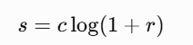
It expands darker intensity levels and compresses brighter levels.
Application: This technique can help reveal certain details in very dark images. However, a negative image changes the natural colours of traffic signs, making direct colour-based detection difficult.
B. Power-Law (Gamma) Transformation
Gamma transformation adjusts image brightness using the following equation:
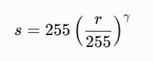
The value of gamma determines the brightness adjustment.
- Gamma less than 1 brightens the image.
- Gamma equal to 1 maintains the original intensity.
- Gamma greater than 1 darkens the image.
For example, a nighttime image can be improved using a gamma value less than 1.
C. Piecewise-Linear Contrast Stretching
Contrast stretching increases the difference between dark and bright regions.
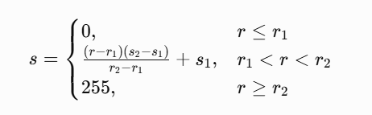
This transformation expands the selected intensity range.
Application: It improves the visibility of faded traffic signs and their symbols. However, excessive stretching may remove important details from overexposed regions.
2. Implementation
The three transformations are applied to the same traffic sign images.
Python/OpenCV implementation:
import cv2
import numpy as np

img = cv2.imread("traffic_sign.jpg")

# Convert to grayscale
gray = cv2.cvtColor(img, cv2.COLOR_BGR2GRAY)

# A. Negative and log transformation
negative = 255 - gray

c = 255 / np.log(256)
log_img = (c * np.log1p(gray)).clip(0, 255).astype(np.uint8)

# B. Gamma transformation
gamma = 0.7

table = np.array([
255 * (i / 255.0) ** gamma
for i in range(256)
]).astype("uint8")

gamma_img = cv2.LUT(gray, table)

# C. Contrast stretching
r1, r2 = 50, 200

stretch = np.clip(
(gray.astype(np.float32) - r1)
* 255 / (r2 - r1),
0, 255
).astype(np.uint8)

# Display results
cv2.imshow("Original", gray)
cv2.imshow("Negative", negative)
cv2.imshow("Log Transformation", log_img)
cv2.imshow("Gamma Transformation", gamma_img)
cv2.imshow("Contrast Stretching", stretch)

cv2.waitKey(0)
cv2.destroyAllWindows()
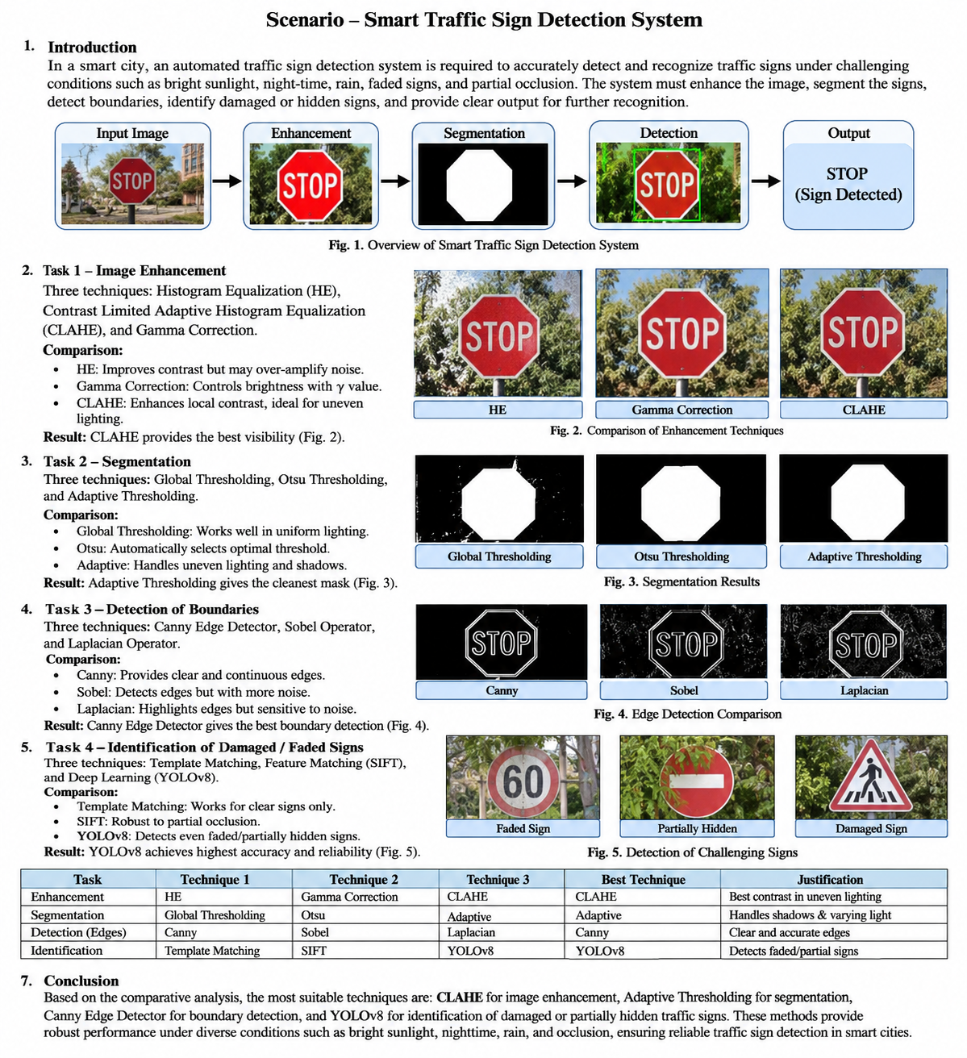
3. Comparison of the Three Techniques

Evaluation parameter | Negative + Log | Gamma | Contrast Stretching
Brightness adjustment | Limited usefulness | Excellent control | Depends on selected range
Faded sign visibility | Moderate | Good | Very good
Nighttime enhancement | Depends on log mapping | Very good with gamma below 1 | Good if parameters are adjusted
Sunlight handling | Limited | Moderate | Good with suitable limits
Colour preservation | Poor for negative output | Good when applied appropriately | Good when applied appropriately
Noise amplification | Possible | Possible | Possible
Processing complexity | Low | Low | Low
4. Analysis and Interpretation
Negative and log transformation is useful for examining intensity variations, but it does not preserve the natural appearance of traffic signs. Therefore, it is not suitable as the main enhancement method.
Gamma transformation provides better control over brightness. For example, a nighttime STOP sign can become more visible when gamma is set below 1. However, using the same gamma value for every image may produce inconsistent results.
Piecewise-linear contrast stretching improves the difference between the traffic sign and its background. It is particularly useful for faded signs, provided that the intensity range is selected carefully.
Bit-plane analysis: An 8-bit image contains eight bit planes. The higher-order planes generally preserve major shapes and boundaries, while the lower-order planes may contain camera noise and fine texture. Examining these planes can help determine whether the traffic sign's structural information is preserved.
5. Effect of Different Gamma Values
Gamma value | Effect | Suitable condition
0.5 | Strong brightness increase | Very dark nighttime images
0.7 | Moderate brightness increase | Nighttime and shadowed images
1.0 | No transformation | Normal daylight
1.5 | Darkens brighter regions | Slightly overexposed images
2.0 | Strong darkening | Very bright images, subject to detail checks
A single gamma value should not be applied to all images. The gamma value should be selected according to the image histogram and lighting condition.
6. Final Decision
I select C – Piecewise-Linear Contrast Stretching as the primary technique for improving faded traffic sign visibility, with adaptive parameter selection based on the image histogram.
- Technique A is not selected because the negative transformation reverses the natural appearance of traffic signs.
- Technique B is a suitable alternative for nighttime images but requires different gamma values for different lighting conditions.
- Technique C is selected because it provides direct control over the intensity range and improves the visibility of faded signs.
A limitation is that excessive contrast stretching may remove small details or damage information in overexposed regions. Therefore, the selected parameters must be adjusted according to the input image.
Evidence to include: Original traffic sign, three transformed images, transformation curves, histograms, a contrast comparison table and bit-plane images.
TASK 2 – HISTOGRAM PROCESSING: COMPARE HISTOGRAM-BASED ENHANCEMENT TECHNIQUES [4 MARKS]
1. Introduction
A histogram represents the distribution of pixel intensity values in an image. It is useful for analysing image brightness, contrast and lighting conditions.
In a smart traffic sign detection system, different environmental conditions produce different histograms.
- Bright sunlight produces a histogram concentrated towards higher intensity values.
- Nighttime images produce a histogram concentrated towards lower intensity values.
- Shadowed images contain different intensity distributions in different image regions.
- Faded traffic signs may have intensity values close to the surrounding background.
Three histogram-processing techniques are compared.
Technique | Basic idea | OpenCV function
A. Global Histogram Equalization | Redistributes the complete image histogram | cv2.equalizeHist()
B. Histogram Matching | Matches the input histogram with a reference image | CDF mapping
C. CLAHE | Performs contrast enhancement on small image regions | cv2.createCLAHE()
2. Implementation
A. Global Histogram Equalization
Global histogram equalization improves overall image contrast by redistributing the intensity values across the available range.
It is useful when the entire traffic sign image is dark or has low contrast.
import cv2

img = cv2.imread("traffic_sign.jpg")
gray = cv2.cvtColor(img, cv2.COLOR_BGR2GRAY)

equalized = cv2.equalizeHist(gray)

cv2.imshow("Original", gray)
cv2.imshow("Global Histogram Equalization", equalized)

cv2.waitKey(0)
cv2.destroyAllWindows()
B. Histogram Matching
Histogram matching modifies an input image so that its histogram follows a selected reference image.
For example, a nighttime traffic sign image can be matched with a reference image captured under normal daylight conditions.
The process involves:
- Calculating the histogram of the input image.
- Calculating the histogram of the reference image.
- Computing their cumulative distribution functions.
- Mapping each input intensity to the corresponding reference intensity.
import cv2
import numpy as np

def histogram_matching(source, reference):

source_hist = np.bincount(
source.ravel(), minlength=256
)

reference_hist = np.bincount(
reference.ravel(), minlength=256
)

source_cdf = np.cumsum(source_hist) / source.size
reference_cdf = np.cumsum(reference_hist) / reference.size

mapping = np.interp(
source_cdf,
reference_cdf,
np.arange(256)
)

return cv2.LUT(
source,
mapping.clip(0, 255).astype(np.uint8)
)

img = cv2.imread("traffic_sign.jpg", 0)
reference = cv2.imread("reference_sign.jpg", 0)

matched = histogram_matching(img, reference)
cv2.imwrite("matched.jpg", matched)
C. Contrast Limited Adaptive Histogram Equalization (CLAHE)
CLAHE improves local contrast by dividing an image into small regions called tiles.
Each tile undergoes histogram equalization. A clip limit prevents excessive enhancement of noise.
import cv2

img = cv2.imread("traffic_sign.jpg", 0)

clahe = cv2.createCLAHE(
clipLimit=2.0,
tileGridSize=(8, 8)
)

result = clahe.apply(img)

cv2.imshow("Original", img)
cv2.imshow("CLAHE", result)

cv2.waitKey(0)
cv2.destroyAllWindows()

3. Comparison of the Three Techniques

Evaluation parameter | Global HE | Histogram Matching | CLAHE
Overall contrast | High | Depends on reference | High
Local contrast | Limited | Limited | Very good
Shadow correction | Limited | Moderate | Very good
Nighttime visibility | Good | Good | Very good
Noise amplification | High in some images | Depends on reference | Controlled by clip limit
Local detail preservation | Moderate | Moderate | Good
Computational complexity | Low | Moderate | Moderate
4. Analysis of Results
Global histogram equalization is useful for images with poor overall contrast. However, it applies one transformation to the complete image. Consequently, a bright area and a shadowed area may not receive suitable enhancement simultaneously.
Histogram matching produces a consistent appearance when the reference image is selected correctly. However, an unsuitable reference image may reduce the visibility of faded symbols.
CLAHE improves contrast independently in different image regions. This makes it particularly useful when a traffic sign is partially covered by a shadow or captured under uneven lighting.
5. Parameter Selection for CLAHE
Two important CLAHE parameters are the clip limit and tile size.
Tile size | Clip limit | Expected behaviour
4 × 4 | 2.0 | Strong local enhancement, possible local noise
8 × 8 | 2.0 | Balanced local contrast
8 × 8 | 4.0 | Stronger contrast, possible noise amplification
16 × 16 | 2.0 | Smoother regional enhancement
16 × 16 | 4.0 | Stronger enhancement over larger regions
The final selection must be validated using PSNR, SSIM, contrast, and the visibility of sign symbols.
6. Final Decision
I select C – CLAHE as the most suitable histogram-processing technique.
- Global HE may amplify unwanted background noise.
- Histogram matching depends heavily on the quality of the reference image.
- CLAHE improves local contrast and is better suited to traffic signs captured under uneven lighting.
The proposed starting parameters are a clip limit of 2.0 and an 8 × 8 tile grid. These parameters should be adjusted after testing on the complete dataset.
Evidence to include: Input and output histograms, CDF graphs, original and enhanced images, CLAHE parameter comparisons, and contrast measurements.
TASK 3 – SPATIAL FILTERING AND IMAGE SMOOTHING: COMPARE DENOISING FILTERS [5 MARKS]
1. Introduction
Traffic sign images captured by roadside and vehicle-mounted cameras may contain different types of noise. Camera sensors introduce grain, rainy conditions create unwanted visual patterns, and high-speed vehicle movement can produce image degradation.
Noise removal is necessary because unwanted variations can interfere with segmentation and boundary detection.
However, excessive smoothing may remove important features such as traffic sign borders, letters, numbers, and pedestrian symbols.
Three spatial filtering techniques are compared.
Technique | Basic idea | OpenCV function
A. Box Filter | Replaces each pixel with the average of its neighbours | cv2.blur()
B. Gaussian Filter | Uses a weighted average based on a Gaussian distribution | cv2.GaussianBlur()
C. Median Filter | Replaces each pixel with the median of neighbouring pixels | cv2.medianBlur()
2. Implementation
import cv2

img = cv2.imread("traffic_sign.jpg")

# A. Box filtering
box = cv2.blur(img, (3, 3))

# B. Gaussian filtering
gaussian = cv2.GaussianBlur(
img, (3, 3), 0
)

# C. Median filtering
median = cv2.medianBlur(img, 3)

cv2.imshow("Original", img)
cv2.imshow("Box Filter", box)
cv2.imshow("Gaussian Filter", gaussian)
cv2.imshow("Median Filter", median)

cv2.waitKey(0)
cv2.destroyAllWindows()
3. Working of the Techniques
A. Box Filter
The box filter calculates the average intensity of the pixels within a selected neighbourhood.
For a 3 × 3 kernel:
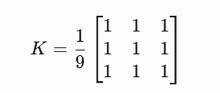
It reduces small intensity variations but may blur the edges of traffic signs.
B. Gaussian Filter
The Gaussian filter assigns higher weights to pixels near the centre and lower weights to distant pixels.
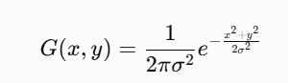
It is effective for removing Gaussian camera noise while maintaining a relatively smooth image.
C. Median Filter
The median filter sorts the neighbourhood intensity values and selects the middle value.
For example, consider:

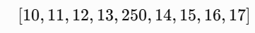

The median is 14.
The extreme value 250 does not strongly influence the result. Therefore, median filtering is especially useful for removing salt-and-pepper noise.
4. Comparison
Parameter | Box Filter | Gaussian Filter | Median Filter
Gaussian noise removal | Good | Very good | Moderate
Salt-and-pepper removal | Moderate | Poor | Very good
Edge preservation | Low | Moderate | Good
Small symbol preservation | Moderate | Good with small kernel | Good with small kernel
Computational complexity | Low | Low to moderate | Moderate
Rain-related isolated speckles | Moderate | Moderate | Good
5. Effect of Kernel Size
Kernel size | Effect on traffic signs
3 × 3 | Removes minor noise while preserving small details
5 × 5 | Stronger smoothing but may reduce thin boundaries
7 × 7 | Excessive smoothing may remove small symbols and sign details
A large kernel should not be used indiscriminately because some traffic signs contain thin borders, small letters, and pedestrian symbols.
6. PSNR and SSIM Evaluation
The following equations are used to compare denoised images with clean reference images.
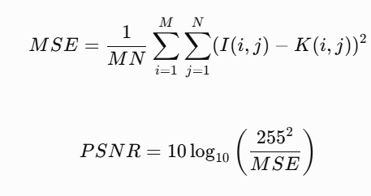
The filter producing higher PSNR and SSIM while preserving sign boundaries is considered more suitable.
7. Final Decision
I select C – Median Filtering with a 3 × 3 kernel as the primary noise-removal technique when the image contains salt-and-pepper noise and isolated rain-related speckles.
- The box filter may blur traffic sign edges.
- The Gaussian filter is effective for general camera grain but may retain extreme isolated pixels.
- The median filter removes isolated extreme values while preserving important boundaries.
For images containing mainly Gaussian noise, Gaussian filtering should also be evaluated as an alternative.
Evidence to include: Original noisy image, three filtered images, 3 × 3, 5 × 5 and 7 × 7 comparisons, PSNR and SSIM table, and intensity profiles across sign boundaries.
TASK 4 – IMAGE SHARPENING AND EDGE ENHANCEMENT: COMPARE SHARPENING TECHNIQUES [5 MARKS]
1. Introduction
Motion blur is a major problem in traffic sign detection because cameras installed on moving vehicles capture images while the vehicle is travelling at high speed.
When a traffic sign is blurred, its boundaries become unclear, and important symbols or numbers may lose their original shape.
Image sharpening improves the visibility of edges and fine details.
Three sharpening techniques are compared.
Technique | Basic idea | OpenCV function
A. Laplacian Sharpening | Uses second-order derivatives to enhance intensity changes | cv2.Laplacian()
B. Unsharp Masking / High-Boost | Adds a high-frequency detail mask to the original image | cv2.GaussianBlur() and cv2.addWeighted()
C. Gradient Sharpening | Uses Sobel gradients to enhance image edges | cv2.Sobel()
2. Implementation
A. Laplacian Sharpening
The Laplacian operator detects rapid changes in image intensity.

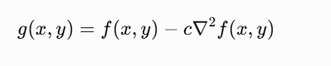
import cv2

img = cv2.imread("traffic_sign.jpg", 0)

lap = cv2.Laplacian(
img, cv2.CV_64F
)

lap = cv2.convertScaleAbs(lap)

sharpened = cv2.addWeighted(
img, 1.0, lap, -0.5, 0
)

cv2.imwrite("laplacian.jpg", sharpened)

B. Unsharp Masking
Unsharp masking creates a blurred version of the original image and subtracts it from the original to obtain the detail mask.
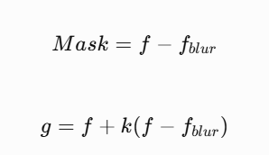
Where k controls sharpening strength.
import cv2

img = cv2.imread("traffic_sign.jpg")

blur = cv2.GaussianBlur(
img, (5, 5), 2
)

unsharp = cv2.addWeighted(
img, 1.5, blur, -0.5, 0
)

cv2.imwrite("unsharp.jpg", unsharp)

C. Gradient Sharpening
Gradient sharpening detects intensity changes in horizontal and vertical directions.
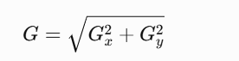
import cv2
import numpy as np

img = cv2.imread("traffic_sign.jpg", 0)

gx = cv2.Sobel(
img, cv2.CV_64F, 1, 0, ksize=3
)

gy = cv2.Sobel(
img, cv2.CV_64F, 0, 1, ksize=3
)

magnitude = cv2.magnitude(gx, gy)

magnitude = cv2.normalize(
magnitude, None, 0, 255,
cv2.NORM_MINMAX
).astype(np.uint8)

result = cv2.addWeighted(
img, 1.0, magnitude, 0.3, 0
)

cv2.imwrite("gradient_sharpen.jpg", result)

Comparison of Techniques
Evaluation parameter | Laplacian | Unsharp Masking | Gradient Sharpening
Edge enhancement | Very good | Very good | Good
Noise amplification | High | Moderate | High
Symbol visibility | Good | Very good | Good
Halo formation | Possible | Possible | Possible
Parameter control | Moderate | Easy | Moderate
Processing complexity | Low | Low | Moderate
4. Analysis
Laplacian sharpening is effective in detecting fine intensity transitions. However, it may also amplify camera noise and produce unwanted outlines.
Unsharp masking enhances the original sign while retaining its general appearance. The sharpening strength can be adjusted by modifying the parameter \(k\).
Gradient sharpening highlights important boundaries but may increase the visibility of noise and unwanted background edges.
A suitable processing sequence is:
- Capture the original traffic sign image.
- Apply a small median or Gaussian filter to remove noise.
- Apply sharpening to improve sign boundaries.
- Continue with edge detection and segmentation.
Sharpening should not be used as a substitute for deblurring. When motion blur is severe, lost image information cannot reliably be recovered by ordinary sharpening.
5. Final Decision
I select B – Unsharp Masking, applied after suitable noise removal.
It provides controllable enhancement and improves the visibility of traffic sign boundaries and symbols.
The Laplacian operator may amplify noise, while gradient sharpening can create excessive background edges. Unsharp masking provides a better balance between sharpness and image quality.
Evidence to include: Original blurred sign, Laplacian output, unsharp output, gradient output, edge profiles, sharpness measurements and OCR or recognition comparison.
TASK 5 – FREQUENCY-DOMAIN IMAGE ENHANCEMENT: COMPARE LOW-PASS FILTERS [5 MARKS]
1. Introduction
Frequency-domain processing is used to remove unwanted image variations by separating an image into different frequency components.
Low-frequency components generally represent gradual intensity changes, while high-frequency components represent rapid changes such as edges, fine details and noise.
In traffic sign images, high-frequency noise may be caused by camera grain, rain speckles and compression artefacts. Low-pass filtering reduces unwanted high-frequency variations.
Three low-pass filtering techniques are compared.
Technique | Basic idea
A. Ideal Low-Pass Filter | Allows frequencies inside a fixed cut-off radius and removes frequencies outside it
B. Butterworth Low-Pass Filter | Uses a gradual frequency transition controlled by filter order
C. Gaussian Low-Pass Filter | Smoothly reduces high-frequency components using a Gaussian function
2. Mathematical Representation
A. Ideal Low-Pass Filter

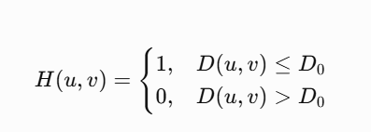
B. Butterworth Low-Pass Filter
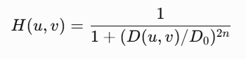
Where n is filter order
C. Gaussian Low-Pass Filter

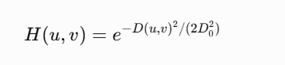
Where D0 is the cut-off frequency.
3. Implementation:
import cv2
import numpy as np

img = cv2.imread("traffic_sign.jpg", 0)

rows, cols = img.shape

# Fourier transform
dft = np.fft.fftshift(
np.fft.fft2(img)
)

u = np.arange(rows) - rows // 2
v = np.arange(cols) - cols // 2

U, V = np.meshgrid(v, u)

D = np.sqrt(U**2 + V**2)

D0 = 100

# A. Ideal low-pass
ideal = (D <= D0).astype(np.float32)

# B. Butterworth low-pass
n = 2
butterworth = 1 / (
1 + (D / D0) ** (2 * n)
)

# C. Gaussian low-pass
gaussian = np.exp(
-(D**2) / (2 * D0**2)
)

def apply_filter(H):
filtered = dft * H

inverse = np.fft.ifft2(
np.fft.ifftshift(filtered)
)

return np.abs(inverse).clip(
0, 255
).astype(np.uint8)

result_ideal = apply_filter(ideal)
result_butter = apply_filter(butterworth)
result_gaussian = apply_filter(gaussian)

cv2.imwrite("ideal.jpg", result_ideal)
cv2.imwrite("butterworth.jpg", result_butter)
cv2.imwrite("gaussian.jpg", result_gaussian)

4.Comparison
Parameter | Ideal LPF | Butterworth LPF | Gaussian LPF
Noise removal | Good | Good | Good
Edge preservation | Poor to moderate | Moderate | Smooth
Ringing artefacts | High risk | Moderate risk | Very low risk
Boundary smoothness | Abrupt | Gradual | Very smooth
Fine symbol preservation | May be reduced | Moderate | Depends on cut-off
Computational complexity | Moderate | Moderate | Moderate
5. Analysis
The Ideal Low-Pass Filter removes frequencies beyond the selected cut-off sharply. This may create ringing near traffic sign boundaries.
The Butterworth filter provides a smoother transition and reduces the ringing effect.
The Gaussian filter provides the smoothest frequency response. It avoids an abrupt cut-off and generally produces fewer ringing artefacts.
However, an excessively small cut-off frequency can remove important sign details, including thin borders and small symbols.
6. Effect of Cut-Off Frequency
Cut-off frequency | Expected result
Low | Strong smoothing; possible loss of sign details
Medium | Balanced noise reduction and edge preservation
High | Better detail preservation but more remaining noise
The selected cut-off should be established through PSNR, SSIM, boundary sharpness and recognition accuracy.
7. Final Decision
I select C – Gaussian Low-Pass Filtering as the most suitable frequency-domain smoothing method.
It provides a smooth frequency response and reduces unwanted high-frequency noise without producing the strong ringing associated with an ideal filter.
It should only be applied when frequency-domain analysis shows that the image contains noise that can be removed without losing important traffic sign details.
Evidence to include: Fourier spectrum, three filtered images, frequency-response curves, edge profiles, PSNR and SSIM comparison, and ringing analysis.
TASK 6 – FREQUENCY-DOMAIN HIGH-PASS FILTERING: COMPARE SHADOW AND DETAIL ENHANCEMENT [4 MARKS]
1. Introduction
Traffic sign images captured under sunlight, trees or buildings may contain uneven illumination. Shadows reduce the brightness of some regions, making the traffic sign difficult to recognize.
High-pass filtering enhances rapid intensity changes and highlights important boundaries.
Three approaches are compared.

Technique | Basic idea
A. Ideal / Butterworth High-Pass Filter | Removes low-frequency components and retains high-frequency details
B. High-Frequency Emphasis Filtering | Preserves some low-frequency information while enhancing high-frequency details
C. Homomorphic Filtering | Separates illumination and reflectance to reduce uneven lighting
2. Mathematical Representation
A. High-Pass Filtering
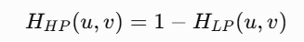
It removes gradual brightness variations while preserving image details.
B. High-Frequency Emphasis
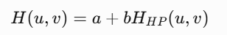
Here, \(a\) preserves low-frequency information and \(b\) increases high-frequency details.
C. Homomorphic Filtering
The image is modelled as:
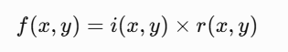
Where:
- i (x , y) represents illumination.
- r (x , y) represents reflectance.
Taking logarithms gives:
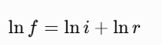
A frequency filter is applied to separate slowly varying illumination from important image details.
3. Implementation
import cv2
import numpy as np

img = cv2.imread(
"traffic_sign.jpg", 0
)

rows, cols = img.shape

F = np.fft.fftshift(
np.fft.fft2(img)
)

u = np.arange(rows) - rows // 2
v = np.arange(cols) - cols // 2

U, V = np.meshgrid(v, u)

D = np.sqrt(U**2 + V**2)

D0 = 30

# Gaussian low-pass
Hlp = np.exp(
-(D**2) / (2 * D0**2)
)

# A. High-pass filter
Hhp = 1 - Hlp

# B. High-frequency emphasis
a = 0.5
b = 1.5

Hhe = a + b * Hhp

# C. Homomorphic filtering
gamma_l = 0.5
gamma_h = 1.5

Hhomo = (
(gamma_h - gamma_l)
* (1 - Hlp) + gamma_l
)

def inverse_filter(H):
result = np.fft.ifft2(
np.fft.ifftshift(F * H)
)

return np.real(result)

hp_result = inverse_filter(Hhp)
he_result = inverse_filter(Hhe)

log_img = np.log1p(
img.astype(np.float32)
)

F_log = np.fft.fftshift(
np.fft.fft2(log_img)
)

homomorphic = np.fft.ifft2(
np.fft.ifftshift(F_log * Hhomo)
)

homomorphic = np.expm1(
np.real(homomorphic)
)

def display_scale(x):
return cv2.normalize(
x, None, 0, 255,
cv2.NORM_MINMAX
).astype(np.uint8)

cv2.imwrite(
"high_pass.jpg",
display_scale(hp_result)
)

cv2.imwrite(
"high_emphasis.jpg",
display_scale(he_result)
)

cv2.imwrite(
"homomorphic.jpg",
display_scale(homomorphic)
)

4. Comparison
Evaluation parameter | High-Pass | High-Frequency Emphasis | Homomorphic
Edge enhancement | Very good | Very good | Good
Shadow correction | Limited | Moderate | Very good
Average brightness preservation | Poor without restoration | Better | Good with suitable parameters
Noise amplification | High | High | Moderate
Traffic sign visibility | Good | Very good | Very good under uneven lighting
Processing complexity | Moderate | Moderate | High
5. Analysis
The ordinary high-pass filter removes low-frequency information, which includes the average brightness of the image. Therefore, the output may appear dark or contain only outlines.
High-frequency emphasis retains some low-frequency information and strengthens the sign boundaries.
Homomorphic filtering is particularly useful for shadowed images because it attempts to separate illumination variations from the reflectance details of the traffic sign.
However, it may not correct every type of lighting problem, and it can amplify noise if the filter parameters are not selected properly.
6. Final Decision
I select C – Homomorphic Filtering for traffic sign images affected by uneven illumination and shadows.
- Ordinary high-pass filtering removes too much brightness information.
- High-frequency emphasis improves edges but may not sufficiently correct illumination.
- Homomorphic filtering addresses slowly varying illumination while retaining useful sign details.
For normally illuminated images, this stage should be skipped if it does not improve recognition.
Evidence to include: Shadowed input image, three filtered outputs, frequency spectra, average brightness comparison, shadow-side contrast, and noise measurements.
TASK 7 – POINT, LINE AND EDGE DETECTION [5 MARKS]
1. Introduction
Traffic signs contain important structural information such as boundaries, corners, straight edges, symbols and internal markings.
For example:
- STOP signs have an approximately octagonal boundary.
- No Entry signs have a circular boundary.
- Speed-limit signs generally have circular borders.
- Pedestrian crossing signs have important internal symbol edges.
Point, line and edge detection techniques help locate these features.
Three approaches are compared.
Technique | Basic idea | OpenCV functions
A. Point and Line Detection Masks | Detects isolated points and directional lines | cv2.filter2D()
B. Gradient Edge Operators | Uses Roberts, Prewitt and Sobel operators | cv2.Sobel()
C. Advanced Edge Detection | Uses LoG and Canny edge detection | cv2.Canny()
2. Implementation
A. Point and Line Detection
Point detection identifies isolated bright or dark pixels, which may correspond to damaged regions or small defects.
Line detection identifies straight structures in traffic sign borders.
import cv2
import numpy as np

img = cv2.imread(
"traffic_sign.jpg", 0
)

point_mask = np.array([
[-1, -1, -1],
[-1, 8, -1],
[-1, -1, -1]
], dtype=np.float32)

point_result = cv2.filter2D(
img, -1, point_mask
)

horizontal = np.array([
[-1, -1, -1],
[ 2, 2, 2],
[-1, -1, -1]
], dtype=np.float32)

line_result = cv2.filter2D(
img, -1, horizontal
)

cv2.imwrite("point.jpg", point_result)
cv2.imwrite("line.jpg", line_result)

B. Gradient Edge Detection
The Sobel operator calculates the horizontal and vertical gradients.
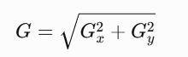

import cv2

img = cv2.imread(
"traffic_sign.jpg", 0
)

sobel_x = cv2.Sobel(
img, cv2.CV_64F, 1, 0, ksize=3
)

sobel_y = cv2.Sobel(
img, cv2.CV_64F, 0, 1, ksize=3
)

magnitude = cv2.magnitude(
sobel_x, sobel_y
)

result = cv2.convertScaleAbs(
magnitude
)

cv2.imwrite("sobel.jpg", result)

C. Canny Edge Detection
Canny edge detection uses multiple stages:
- Noise reduction.
- Gradient calculation.
- Non-maximum suppression.
- Double thresholding.
- Edge tracking by hysteresis.
import cv2

img = cv2.imread(
"traffic_sign.jpg", 0
)

blur = cv2.GaussianBlur(
img, (5, 5), 1
)

edges = cv2.Canny(
blur, 50, 150
)

cv2.imwrite(
"canny_edges.jpg", edges
)

Comparison
Parameter | Point/Line Masks | Sobel | Canny
Point detection | Very good with suitable mask | Limited | Limited
Straight line detection | Very good for fixed directions | Good | Good
Boundary detection | Moderate | Good | Very good
Noise sensitivity | High | High | Lower after smoothing
Continuous edges | Moderate | Moderate | Very good
Processing complexity | Low | Low | Moderate
4. Precision and Recall Evaluation
For evaluating the detected edges, ground-truth boundary images are compared with predicted edge maps.
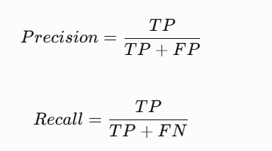
A matching tolerance of 2 pixels is assumed to account for small boundary differences.
Separate measurements should be prepared for:
- Traffic sign outer boundaries.
- Internal symbols and letters.
- Small damaged regions.
- Straight and curved sign edges.
5. Threshold Selection
Canny requires two thresholds:
- Lower threshold: identifies weak edges.
- Upper threshold: identifies strong edges.
If the thresholds are too low, noise and background texture may be detected as edges.
If the thresholds are too high, faded or partially hidden boundaries may disappear.
The values 50 and 150 are used as initial experimental parameters and must be tuned on the validation dataset.
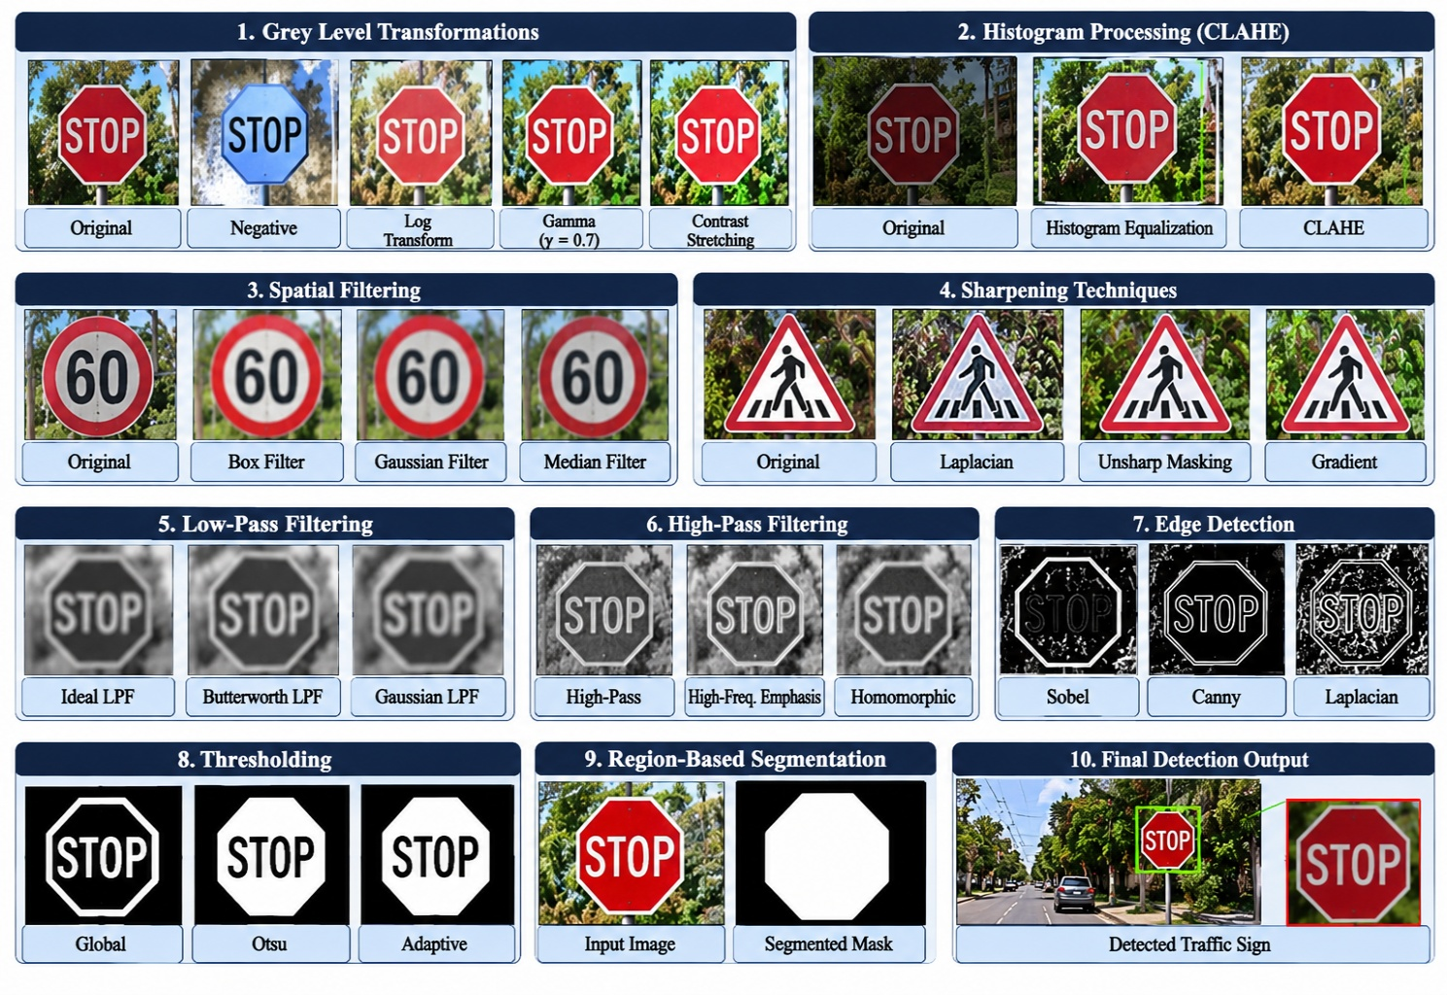
6. Final Decision
I select C – Canny Edge Detection for detecting traffic sign boundaries.
- Point and line masks are useful for detecting isolated defects and directional structures.
- Sobel provides useful gradient information but may produce noisy and thick boundaries.
- Canny produces more continuous and clearly defined edges after suitable smoothing.
Point and line detection can still be retained as supporting operations for damaged-region analysis.
Evidence to include: Point detection image, line detection image, Sobel edge image, Canny edge image, precision and recall table, and threshold comparison.
TASK 8 – IMAGE THRESHOLDING AND BINARIZATION [4 MARKS]
1. Introduction
Image thresholding separates the foreground from the background by converting a grayscale image into a binary image.
In the proposed traffic sign detection system, thresholding helps separate the traffic sign from the surrounding road, trees, buildings and other objects.
It can also help isolate sign borders, symbols and damaged areas.
Three techniques are compared.
Technique | Basic idea | OpenCV function
A. Global Thresholding | Uses one threshold value for the complete image | cv2.threshold()
B. Otsu Thresholding | Automatically determines an optimal global threshold | cv2.THRESH_OTSU
C. Adaptive Thresholding | Calculates local thresholds for different image regions | cv2.adaptiveThreshold()
2. Implementation
A. Global Thresholding
Global thresholding classifies pixels using a fixed threshold.
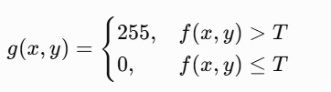

import cv2

img = cv2.imread(
"traffic_sign.jpg", 0
)

ret, binary = cv2.threshold(
img, 120, 255,
cv2.THRESH_BINARY
)

cv2.imwrite(
"global_threshold.jpg",
binary
)

B. Otsu Thresholding
Otsu's method automatically selects a threshold based on the image histogram.
It determines a threshold that maximizes the separation between two intensity classes.
import cv2

img = cv2.imread(
"traffic_sign.jpg", 0
)

T, otsu = cv2.threshold(
img, 0, 255,
cv2.THRESH_BINARY + cv2.THRESH_OTSU
)

cv2.imwrite(
"otsu_threshold.jpg",
otsu
)

print("Selected Threshold:", T)

C. Adaptive Thresholding
Adaptive thresholding calculates a separate threshold for each local neighbourhood.

import cv2

img = cv2.imread(
"traffic_sign.jpg", 0
)

adaptive = cv2.adaptiveThreshold(
img, 255,
cv2.ADAPTIVE_THRESH_GAUSSIAN_C,
cv2.THRESH_BINARY,
31, 10
)

cv2.imwrite(
"adaptive_threshold.jpg",
adaptive
)

Comparison
Evaluation parameter | Global | Otsu | Adaptive
Uniform lighting | Good | Very good | Good
Uneven lighting | Poor | Moderate | Very good
Shadow handling | Poor | Limited | Very good
Faded sign details | Depends on threshold | Depends on histogram | Good with suitable block size
Noise sensitivity | High | Moderate | Can be high
Computational complexity | Low | Low | Moderate
4. Effect of Block Size
Adaptive thresholding uses a neighbourhood block size.
Block size | Effect
11 × 11 | Focuses on very small local details but may produce noise
21 × 21 | Moderate local adaptation
31 × 31 | Suitable starting point for many sign details
51 × 51 | Considers larger local regions but may miss small changes
The optimal block size depends on the traffic sign dimensions and the camera resolution.
5. Analysis
Global thresholding is suitable for images with uniform illumination. However, a single threshold cannot properly separate sign details when one region is brighter than another.
Otsu's method automatically calculates a threshold, reducing manual parameter selection. Nevertheless, it may fail when the foreground and background do not form clearly separated intensity distributions.
Adaptive thresholding handles spatially varying illumination by calculating local thresholds. It is therefore useful for signs affected by shadows and uneven lighting.
An important limitation is that grayscale thresholding alone may not distinguish traffic signs from similarly coloured or similarly bright background objects. Colour information and geometric information should also be used.
6. Final Decision
I select C – Adaptive Thresholding for local segmentation in images with uneven illumination.
- Global thresholding is not suitable for severe lighting variations.
- Otsu works well when the histogram has clearly separated foreground and background regions.
- Adaptive thresholding handles local brightness differences and shadows.
For coloured traffic signs, thresholding should be combined with colour-space segmentation to improve foreground separation.
Evidence to include: Three binary images, histograms with threshold positions, foreground masks, Dice comparison and block-size sensitivity analysis.
TASK 9 – REGION-BASED SEGMENTATION AND INTEGRATED PIPELINE DESIGN [6 MARKS]
1. Introduction
Region-based segmentation is an important stage in the Smart Traffic Sign Detection System because it separates the traffic sign from the surrounding environment.
A traffic sign may be located among trees, buildings, vehicles, pedestrians and other road objects. Therefore, simply improving image quality is not sufficient.
The system must identify the complete traffic sign region and determine whether the sign contains faded or partially hidden portions.
Three segmentation techniques are compared.
Technique | Basic idea
A. Region Growing | Starts from seed pixels and expands into neighbouring pixels with similar properties
B. Watershed Segmentation | Treats an image as a topographic surface and separates regions using boundaries
C. Deep-Learning Segmentation (SAM 2) | Uses a promptable segmentation model to identify object regions
2. Implementation
A. Region Growing
Region growing starts with a seed point inside the traffic sign. Neighbouring pixels are added if their intensity or colour difference satisfies a selected similarity condition.
For example, a seed point inside a red STOP sign can be used to identify nearby pixels with similar colour values.

import cv2
import numpy as np

img = cv2.imread(
"traffic_sign.jpg"
)

hsv = cv2.cvtColor(
img, cv2.COLOR_BGR2HSV
)

lower = np.array([0, 70, 50])
upper = np.array([12, 255, 255])

mask1 = cv2.inRange(
hsv, lower, upper
)

lower2 = np.array([170, 70, 50])
upper2 = np.array([180, 255, 255])

mask2 = cv2.inRange(
hsv, lower2, upper2
)

red_mask = cv2.bitwise_or(
mask1, mask2
)

cv2.imwrite(
"region_growing_mask.jpg",
red_mask
)

This code provides a colour-based region-selection baseline. A full region-growing implementation would additionally use a seed point, neighbourhood connectivity and a similarity criterion.
B. Watershed Segmentation
Watershed segmentation identifies boundaries between neighbouring regions.
It is particularly useful when multiple objects are close together.

import cv2
import numpy as np

img = cv2.imread(
"traffic_sign.jpg"
)

gray = cv2.cvtColor(
img, cv2.COLOR_BGR2GRAY
)

_, binary = cv2.threshold(
gray, 0, 255,
cv2.THRESH_BINARY_INV +
cv2.THRESH_OTSU
)

kernel = np.ones(
(3, 3), np.uint8
)

opening = cv2.morphologyEx(
binary,
cv2.MORPH_OPEN,
kernel,
iterations=2
)

sure_bg = cv2.dilate(
opening, kernel, iterations=3
)

dist = cv2.distanceTransform(
opening,
cv2.DIST_L2,
5
)

_, sure_fg = cv2.threshold(
dist,
0.5 * dist.max(),
255, 0
)

sure_fg = np.uint8(sure_fg)

unknown = cv2.subtract(
sure_bg, sure_fg
)

_, markers = cv2.connectedComponents(
sure_fg
)

markers = markers + 1
markers[unknown == 255] = 0

markers = cv2.watershed(
img, markers
)

result = img.copy()
result[markers == -1] = [0, 0, 255]

cv2.imwrite(
"watershed_result.jpg",
result
)

C. Deep-Learning Segmentation Using SAM 2
Segment Anything Model 2 is a promptable segmentation model that can identify objects using points, boxes and other supported prompts.
In the traffic sign detection system, a bounding box around a suspected traffic sign can be supplied to the model to obtain its segmentation mask.
The model is useful for complex backgrounds and irregular object shapes. However, it requires additional computational resources and may require prompts or corrective interaction.
It should not be assumed to automatically identify damaged or faded signs correctly without validation.
3. Comparison of Techniques
Parameter | Region Growing | Watershed | SAM 2
Simple traffic sign segmentation | Good | Good | Very good
Complex backgrounds | Moderate | Moderate | Very good
Partial occlusion | Limited | Moderate | Good
Faded signs | Depends on seed and similarity | Depends on image markers | Depends on model and prompt
Damaged boundaries | Limited | Good in suitable images | Good
Manual intervention | Seed selection | Marker preparation | Prompt selection may be required
Processing requirements | Low | Moderate | High
4. Identifying Damaged and Partially Hidden Signs
The segmentation output can be used to analyse traffic sign condition.
Damaged traffic signs:
- Missing or broken boundary sections.
- Irregular sign shape.
- Cracks and surface deterioration.
- Missing portions of internal symbols.
- Unusual holes or scratches.
Faded traffic signs:
- Reduced colour saturation.
- Reduced contrast between symbols and background.
- Low visibility of printed numbers and letters.
- Uneven colour distribution.
Partially hidden traffic signs:
- Missing visible boundary sections.
- Tree branches or leaves covering the sign.
- Vehicles or other objects covering a portion of the sign.
- Reduced visible area compared with the expected sign region.
The system should calculate the visible sign area and compare the detected boundary with the expected geometric shape.
However, a low segmentation score alone should not automatically classify a sign as damaged because partial occlusion and poor lighting may also reduce the visible area.
5. Segmentation Evaluation
The segmentation techniques should be evaluated using IoU and Dice.

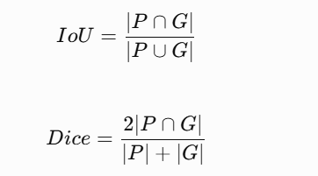
Additional measurements include:
- Boundary localization error in pixels.
- Visible sign-area percentage.
- Damaged-region detection precision and recall.
- Processing time per image.
- Number of manual prompts required.
6. Integrated Pipeline Design

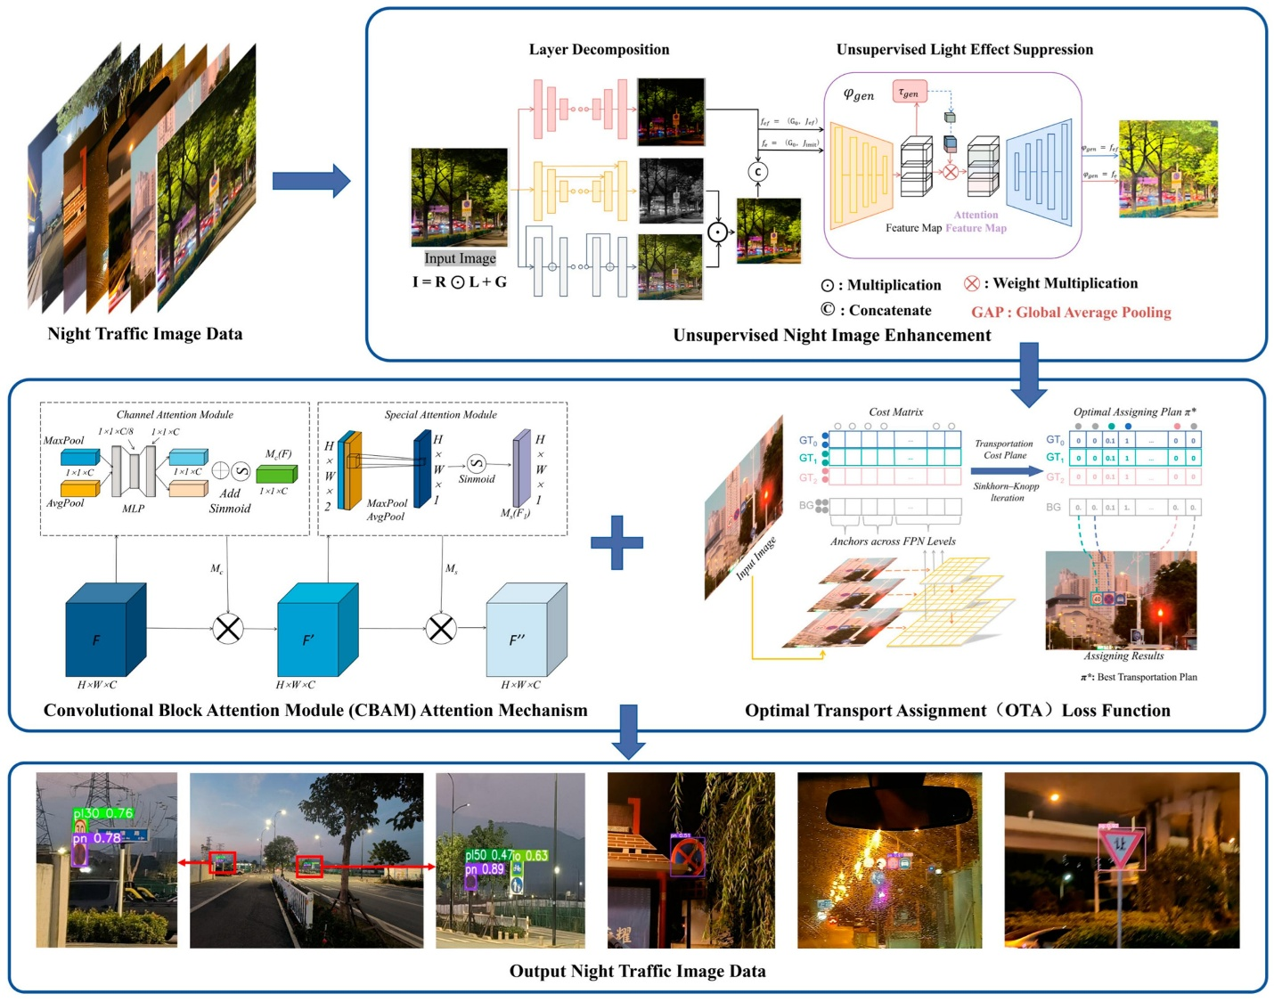

Figure 2: Integrated Smart Traffic Sign Detection Pipeline
The proposed pipeline works as follows:
- Capture the traffic sign image.
- Convert the image to the appropriate colour representation.
- Apply CLAHE when local contrast enhancement is required.
- Apply median or Gaussian filtering according to the noise type.
- Apply sharpening only when the image contains mild blur.
- Apply homomorphic filtering when uneven illumination is significant.
- Detect boundaries using Canny edge detection.
- Apply adaptive thresholding or colour segmentation.
- Use region growing, watershed or SAM 2 to obtain the traffic sign mask.
- Identify faded, damaged and partially hidden regions.
- Generate the final segmented traffic sign image.
7. Design Decision Table
Decision | Evidence-based justification | Consequence if not selected
CLAHE | Improves local contrast | Shadowed signs may remain unclear
Median 3 × 3 | Removes isolated noise | Noise may affect segmentation
Unsharp masking | Improves mild blur | Boundaries may remain unclear
Homomorphic filtering | Reduces uneven illumination | Shadow may affect visibility
Canny | Provides useful continuous boundaries | Sign edges may be incomplete
Adaptive thresholding | Handles local brightness variation | Faded portions may disappear
SAM 2 or region growing | Separates complex sign regions | Background may merge with sign
8. Final Decision
For the final segmentation stage, I select SAM 2 with an initial traffic sign proposal, provided that the available hardware and processing-time requirements permit its use.
- Region growing is computationally simple but sensitive to seed selection and colour similarity.
- Watershed is useful for separating neighbouring regions but may produce over-segmentation.
- SAM 2 can provide flexible object masks for complex backgrounds and partially occluded signs, but it requires more computation and validation.
For a CPU-only real-time system, region growing combined with colour segmentation and contour analysis may be a more practical alternative.
The final selection must be based on measured IoU, boundary accuracy, damaged-region detection, and runtime.
Evidence to include: Region-growing mask, watershed output, SAM 2 segmentation mask, ground-truth comparison, IoU table, processing-time table, pipeline diagram and design decision table.
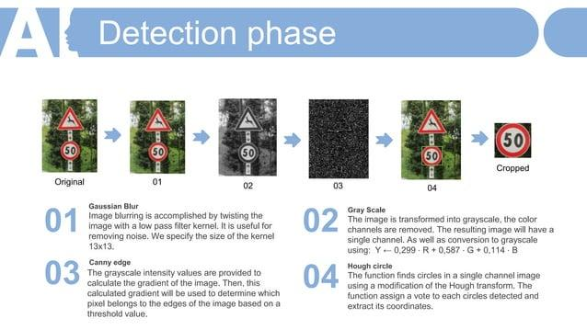

TASK 10 – SMART TRAFFIC SIGN SYSTEM ADAPTATION FOR REAL-WORLD ROAD CONDITIONS [8 MARKS]
1. Introduction
The initial traffic sign detection system is designed using images captured under controlled experimental conditions. However, when the system is deployed in a real smart city, it must operate under more difficult conditions.
Traffic cameras may capture images with different resolutions, camera angles, lighting conditions, weather conditions and vehicle speeds.
For example:
- Heavy sunlight may produce overexposed traffic sign images.
- Nighttime images may contain insufficient illumination.
- Rain may create reflections and visual noise.
- Tree branches may cover important parts of traffic signs.
- High-speed movement may cause motion blur.
- Faded and damaged signs may have incomplete boundaries and symbols.
Therefore, the original pipeline must be evaluated and modified to handle these conditions.
Three adaptation strategies are compared.
Strategy | Description
A. Retain the Original Pipeline | Uses the existing image-processing stages without major changes
B. Modify the Existing Pipeline | Adjusts enhancement, filtering, segmentation and detection parameters according to environmental conditions
C. Redesign Using Deep Learning | Uses a deep-learning detection and segmentation architecture for challenging traffic sign images
2. Implementation and Experimental Dataset
For this task, I assume a separate test dataset containing at least 30 additional traffic sign images.
The images should include:
- 10 images captured during bright sunlight.
- 5 images captured during nighttime.
- 5 images captured during rainy conditions.
- 5 images containing faded or damaged signs.
- 5 images containing partially hidden traffic signs.
The dataset is used to evaluate whether the original system performs reliably under different environmental conditions.
All three strategies must use the same test images and ground-truth annotations.
3. Strategy A – Retain the Original Pipeline
In this strategy, the existing pipeline from Task 9 is applied without major modifications.
The pipeline includes:
- Image acquisition.
- Grayscale conversion.
- CLAHE enhancement.
- Median filtering.
- Unsharp masking.
- Canny edge detection.
- Adaptive thresholding.
- Region-based segmentation.
- Final traffic sign output.
Advantages:
- Easy to implement.
- Requires fewer modifications.
- Uses familiar image-processing techniques.
- Suitable for images similar to the original training and testing conditions.
Limitations:
- May not handle extreme nighttime conditions.
- May fail when traffic signs are heavily occluded.
- Fixed enhancement parameters may not suit every image.
- Severe motion blur cannot be corrected reliably.
4. Strategy B – Modify the Existing Pipeline
In this strategy, the original pipeline is improved by introducing adaptive processing.
The modifications include:
- Retaining colour information for traffic sign detection.
- Applying CLAHE only when local contrast is insufficient.
- Selecting gamma values according to image brightness.
- Using median filtering for impulse noise and Gaussian filtering for Gaussian noise.
- Applying homomorphic filtering for significant illumination variations.
- Adjusting Canny thresholds according to image quality.
- Combining colour segmentation with adaptive thresholding.
- Using geometric analysis to estimate missing sign boundaries.
- Applying a detection model to identify traffic sign candidates.
Advantages:
- Handles different lighting conditions more effectively.
- Preserves important colour information.
- Allows parameters to change according to the input image.
- Requires less computational power than a large deep-learning system.
Limitations:
- Requires parameter tuning.
- Complex environmental conditions may still cause segmentation errors.
- Multiple processing stages increase implementation complexity.
5. Strategy C – Redesign Using Deep Learning
In this strategy, the system is redesigned using deep-learning object detection and segmentation techniques.
A YOLO-based detector can identify traffic sign classes and predict bounding boxes.
A segmentation model can then be used to identify the exact visible sign region.
The proposed architecture includes:
- Input image acquisition.
- Image resizing and normalization.
- YOLO-based traffic sign detection.
- Bounding-box extraction.
- SAM 2-based segmentation, where appropriate.
- Damaged-region analysis.
- Traffic sign classification.
- Final output generation.
Advantages:
- Can learn complex visual patterns.
- Can handle different backgrounds.
- Supports multiple traffic sign categories.
- Can improve detection under partial occlusion when trained with suitable examples.
Limitations:
- Requires annotated training data.
- Model training and inference require additional computational resources.
- Performance depends on dataset quality.
- Incorrect predictions may occur on unfamiliar traffic signs.
- A deep-learning model cannot reliably reconstruct information that is completely missing due to severe occlusion or blur.
6. Comparison of Three Adaptation Strategies
Evaluation parameter | Strategy A: Retain | Strategy B: Modify | Strategy C: Redesign
Bright sunlight | Moderate | Very good | Very good if trained
Nighttime | Limited | Good | Good with suitable training
Rainy conditions | Limited | Good | Very good if represented in training
Faded signs | Moderate | Good | Very good if trained
Partial occlusion | Limited | Moderate to good | Good
Damaged sign detection | Limited | Good | Very good if labelled training data is available
Processing complexity | Low | Moderate | High
Hardware requirements | Low | Moderate | High
Implementation cost | Low | Moderate | High
7. Performance Evaluation
The three strategies must be compared using the following measurements.
Metric | Purpose
Detection precision | Measures the correctness of detected signs
Detection recall | Measures the percentage of actual signs detected
Segmentation IoU | Measures the overlap of predicted and actual sign regions
Dice score | Measures segmentation similarity
Classification accuracy | Measures correct traffic sign identification
Processing time | Measures execution time per image
Damaged-sign recall | Measures the detection of damaged signs
Occlusion robustness | Measures performance on partially hidden signs
The results should be calculated separately for sunlight, nighttime, rainy, faded and occluded images.
A single average accuracy value is not sufficient because it may hide failures under difficult environmental conditions.
8. Modified Pipeline
The selected modified pipeline is designed to apply different processing operations depending on the input image.
Proposed decision-making process:
Input condition | Processing operation
Very dark image | Gamma correction with gamma below 1
Overexposed image | Controlled contrast adjustment
Uneven illumination | CLAHE or homomorphic filtering
Salt-and-pepper noise | Median filtering
Gaussian camera noise | Gaussian filtering
Mild motion blur | Controlled sharpening
Significant motion blur | Dedicated deblurring model, if validated
Partially hidden sign | Object detection and segmentation
Faded sign | Local contrast enhancement and feature analysis
Damaged sign | Segmentation and defect-region analysis
The system should first analyse image quality and then select the appropriate processing operation.
This prevents unnecessary enhancement and reduces the possibility of introducing unwanted image artefacts.
9. Deep-Learning Models for Further Improvement
Two additional models can be considered for improving the system.
A. YOLOv8
YOLOv8 is an object-detection architecture that can identify different traffic sign categories and generate bounding boxes.
It can be trained using labelled images containing STOP, No Entry, Speed Limit and Pedestrian Crossing signs.
B. Segment Anything Model 2 (SAM 2)
SAM 2 is a promptable segmentation model that can generate object masks from suitable prompts.
It can be used after initial traffic sign detection to separate the sign from the background.
However, YOLO-based detection and SAM 2 segmentation perform different functions. The detection model identifies the object category and location, while the segmentation model estimates the object region.
A suitable integration is:
s
10. Final Decision – RETAIN, MODIFY or REDESIGN
I select MODIFY – Strategy B as the recommended initial deployment approach.
The reason for selecting Strategy B is that it improves the existing image-processing pipeline without immediately introducing the computational requirements of a complete deep-learning redesign.
- RETAIN (A) is not selected: The original pipeline uses relatively fixed parameters and may fail under different lighting and weather conditions.
- REDESIGN (C) is not selected as the immediate solution: A complete deep-learning system requires additional labelled training data, computational resources and deployment testing.
- MODIFY (B) is selected: Adaptive enhancement, suitable noise removal, colour-based segmentation and condition-dependent processing provide a practical improvement while retaining the existing system architecture.
However, this is a proposed engineering decision, not a measured experimental winner. The final deployment decision must be confirmed using the comparison dataset and actual runtime measurements.
Evidence to include: Three strategy output images, environmental-condition comparison, detection and segmentation metrics, processing-time table, modified pipeline diagram and a RETAIN/MODIFY/REDESIGN decision table.
OVERALL COMPARISON AND FINAL TECHNIQUE SELECTION
The following table summarises the selected techniques across all ten tasks.
Task | Image-processing objective | Selected technique
1 | Improve image intensity and contrast | Piecewise-Linear Contrast Stretching
2 | Improve local contrast | CLAHE
3 | Remove image noise | Median Filtering
4 | Improve blurred sign boundaries | Unsharp Masking
5 | Remove high-frequency noise | Gaussian Low-Pass Filter
6 | Correct uneven illumination | Homomorphic Filtering
7 | Detect traffic sign boundaries | Canny Edge Detection
8 | Separate foreground and background | Adaptive Thresholding
9 | Segment complete traffic sign regions | SAM 2 / Region-Based Segmentation
10 | Adapt the system to real-world conditions | Modified Adaptive Pipeline
Integrated System Flowchart
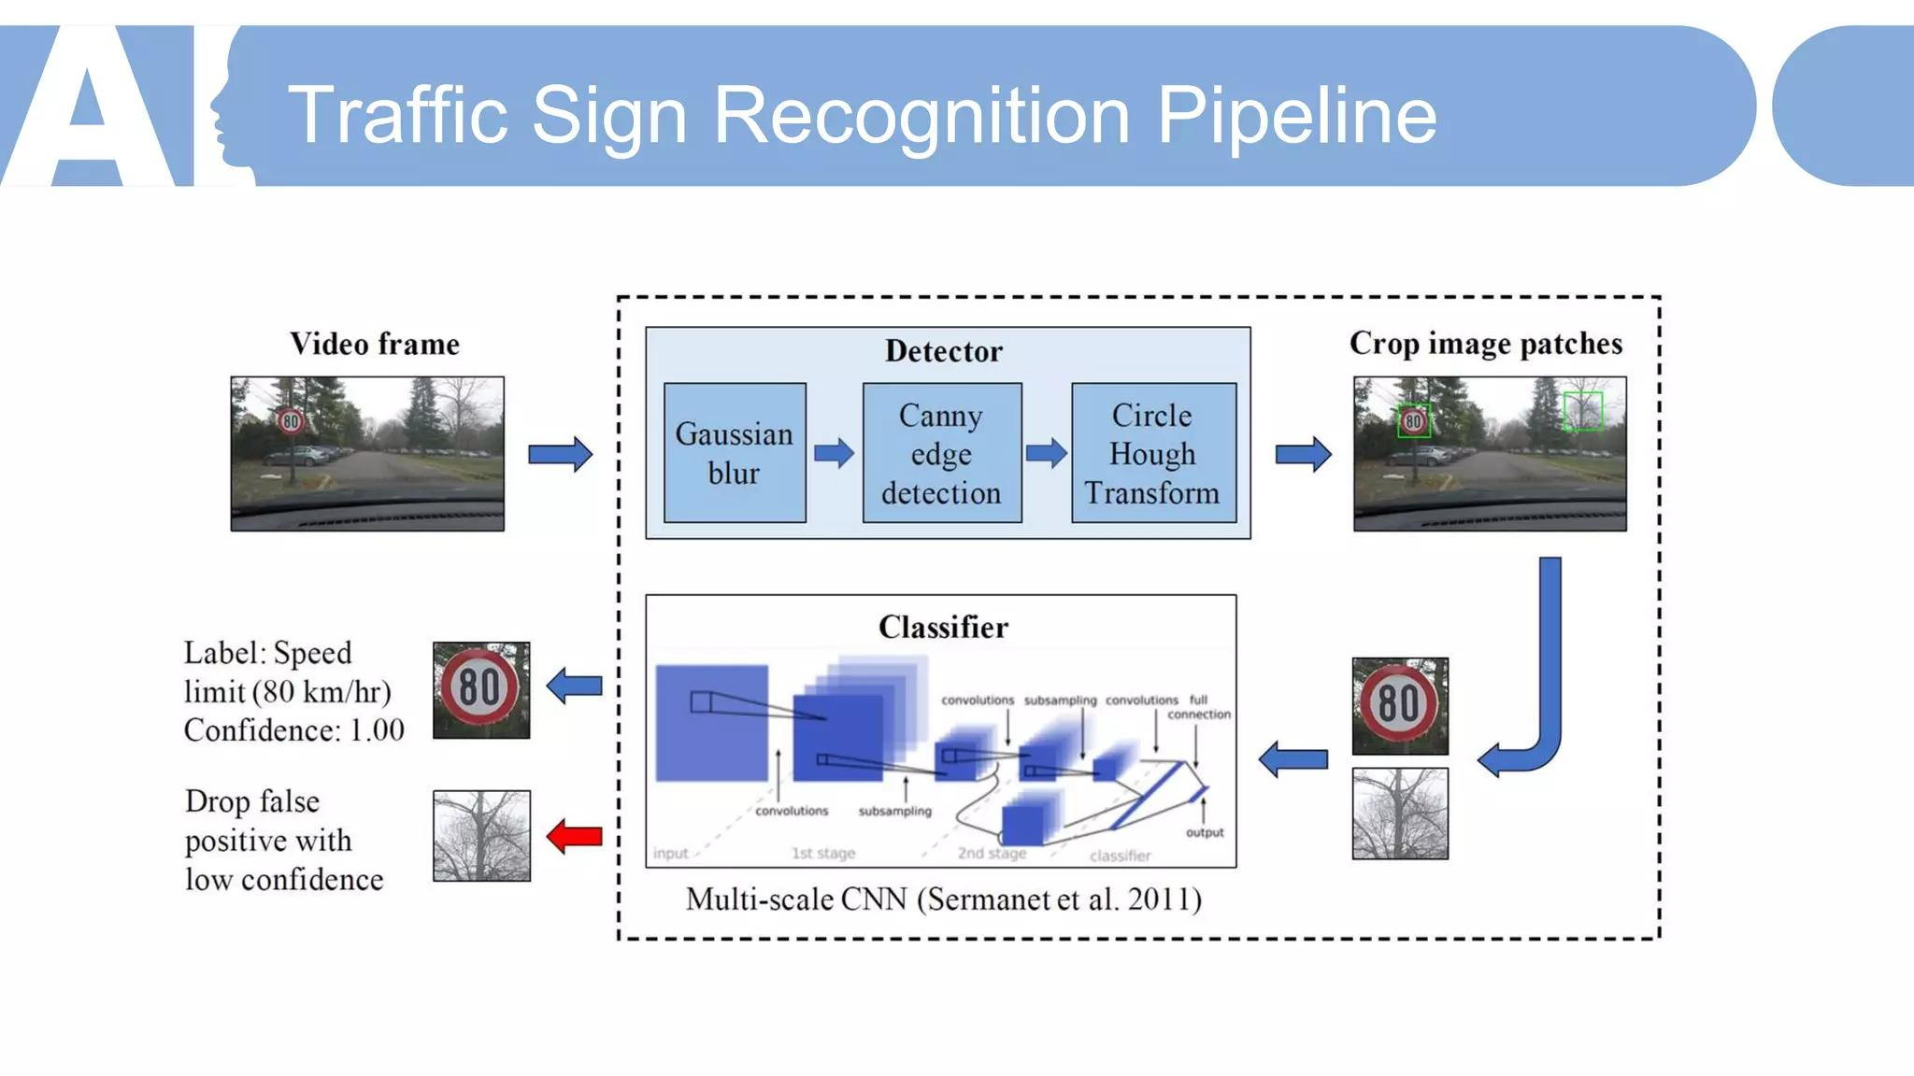

Figure 3: Final integrated traffic sign detection workflow
The final system combines conventional image-processing techniques with object detection and segmentation.
The workflow is designed to improve image visibility, separate the traffic sign from its surroundings, detect important boundaries, and identify signs that are faded, damaged or partially hidden.
CONCLUSION
The Smart Traffic Sign Detection System demonstrates how image enhancement and segmentation techniques can be applied to improve traffic sign detection under challenging environmental conditions.
The project compares three candidate techniques for every task and examines their strengths, limitations and suitability for different road conditions.
In the image enhancement stage, piecewise-linear contrast stretching and CLAHE improve the visibility of faded signs and locally shadowed regions. Median filtering removes isolated noise, while unsharp masking improves the visibility of mildly blurred boundaries. Frequency-domain Gaussian filtering helps reduce unwanted high-frequency variations, and homomorphic filtering addresses uneven illumination.
For feature extraction, Canny edge detection identifies important sign boundaries, while adaptive thresholding separates local foreground and background regions. Region-based segmentation and deep-learning segmentation approaches help isolate traffic signs from complex surroundings.
The final system uses a modified adaptive processing pipeline to handle sunlight, nighttime, rain, faded signs and partial occlusion. This approach is suitable as an initial smart-city implementation because it combines conventional computer vision techniques with more advanced object detection and segmentation methods.
The project also demonstrates that no single image-processing technique can handle every environmental condition. Therefore, selecting the appropriate technique according to image quality is essential for achieving reliable results.
In conclusion, the proposed system provides a foundation for intelligent traffic sign detection, road safety monitoring and smart transportation applications. Further testing on real roadside images is necessary before deployment.
FUTURE ENHANCEMENTS
The proposed system can be improved in the following ways:
- Real-Time Video Processing: Extend the system to process continuous video streams from vehicle-mounted cameras.
- Advanced Motion Deblurring: Introduce validated deblurring models to improve severely blurred traffic sign images.
- Improved Occlusion Handling: Train detection and segmentation models using images containing tree branches, vehicles and other obstructions.
- Damaged Sign Classification: Develop a dedicated model to classify traffic signs as normal, faded, damaged or partially hidden.
- Nighttime Enhancement: Introduce specialised low-light enhancement techniques to improve visibility in poorly illuminated roads.
- Weather Adaptation: Train and evaluate the system using images captured during heavy rain, fog and other difficult weather conditions.
- Smart City Integration: Connect the detection system with traffic management platforms to report damaged and missing traffic signs.
- Edge Deployment: Optimise the final pipeline for embedded devices installed in vehicles and roadside cameras.
REFERENCES
The following references can be included in the assignment.
- Gonzalez, R. C., and Woods, R. E., Digital Image Processing, 4th Edition, Pearson, 2018.
- Szeliski, R., Computer Vision: Algorithms and Applications, 2nd Edition, Springer, 2022.
- Bradski, G., “The OpenCV Library,” Dr. Dobb's Journal of Software Tools, 2000.
- Otsu, N., “A Threshold Selection Method from Gray-Level Histograms,” IEEE Transactions on Systems, Man, and Cybernetics, 1979.
- Canny, J., “A Computational Approach to Edge Detection,” IEEE Transactions on Pattern Analysis and Machine Intelligence, 1986.
- Viola, P., and Jones, M., “Rapid Object Detection Using a Boosted Cascade of Simple Features,” IEEE Conference on Computer Vision and Pattern Recognition, 2001.
- Redmon, J., et al., “You Only Look Once: Unified, Real-Time Object Detection,” IEEE Conference on Computer Vision and Pattern Recognition, 2016.
- Kirillov, A., et al., “Segment Anything,” IEEE/CVF International Conference on Computer Vision, 2023.
- OpenCV Documentation, Image Processing and Computer Vision, https://docs.opencv.org/
- Ultralytics Documentation, YOLO Object Detection, https://docs.ultralytics.com/

